SEP ASSIGNMENT - 3

1.)USE CASE DIAGRAM

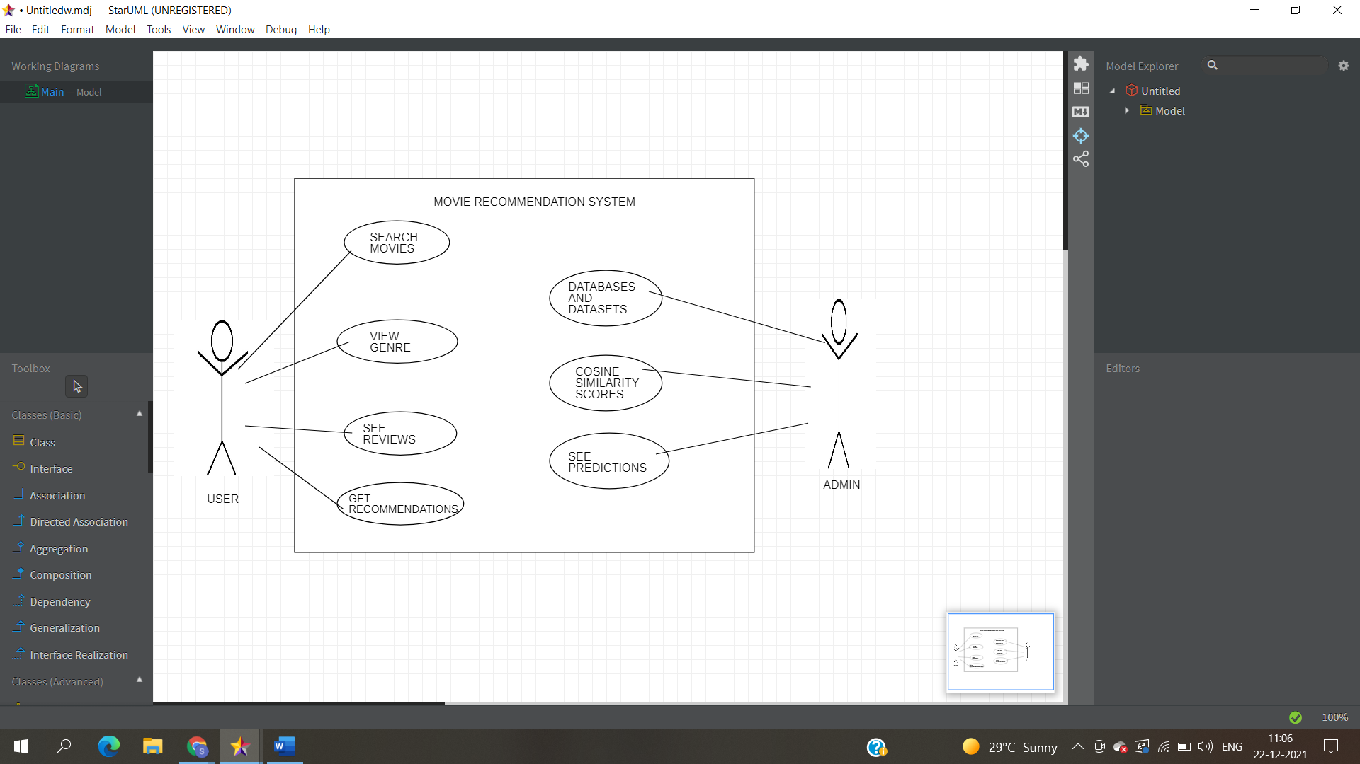

2.)CLASS DIAGRAM

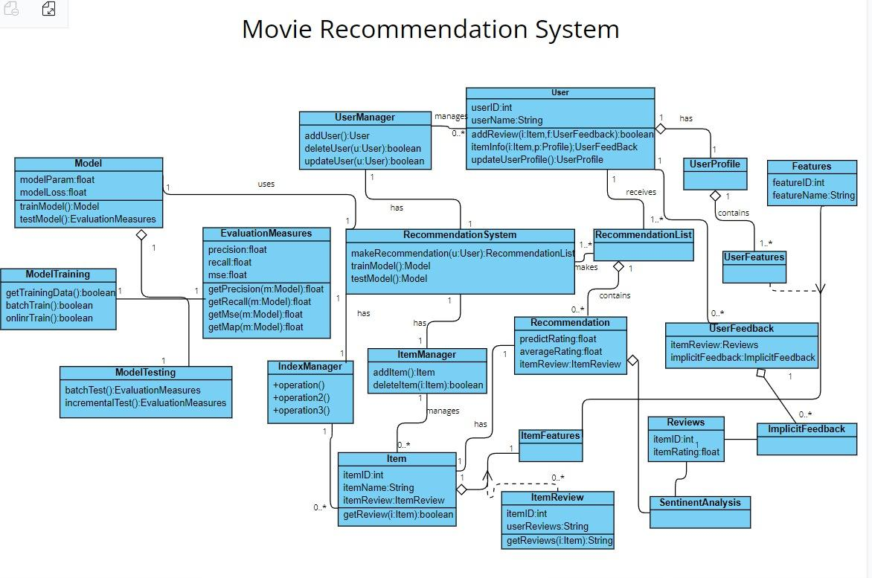

3.)SEQUENCE/COLLABORATION DIAGRAM

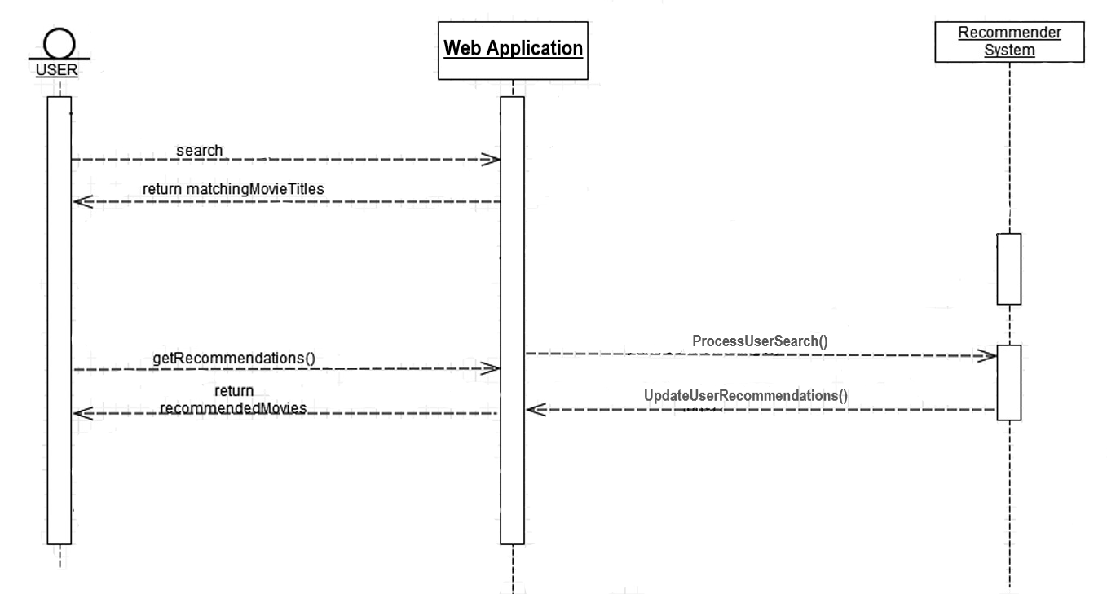

4.)STATECHART/ACTIVITY DIAGRAM:-

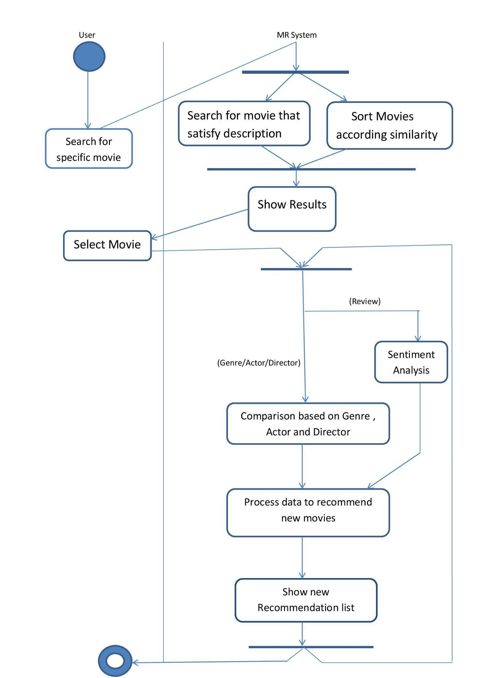

5.)COMPONENT DIAGRAM

